**Where publishing is easy as creating music**

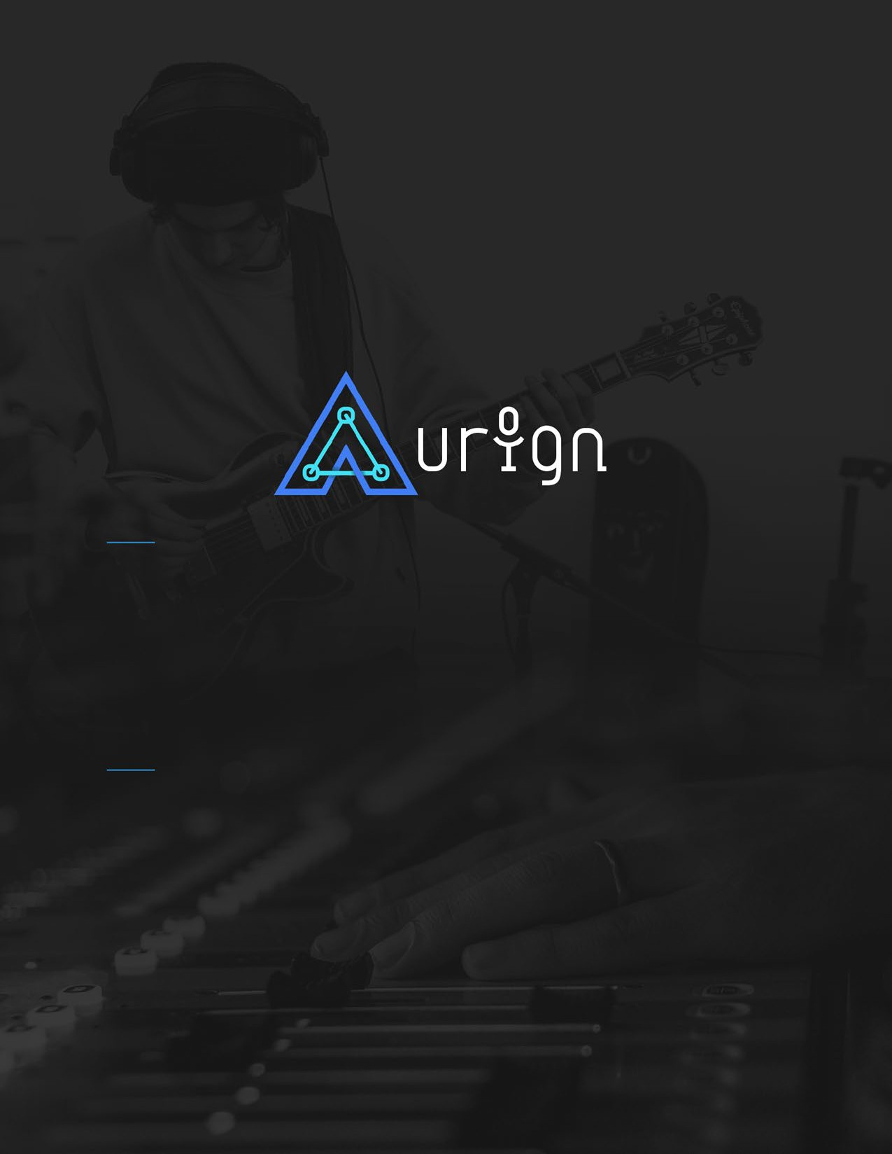

Email: [roberth@soundcollide.com](mailto:roberth@soundcollide.com)

Founder: Robert Hatcher

**EXECUTIVE SUMMARY**

**AURIGN** isa smart collaborative music publishing platform using AI and blockchain technology to eliminate inefficiencies in the publishing supply chain. Founded in 2018 in Atlanta, **Aurign’s** target audience is major record labels, independent record labels, and independent music artists. The potential market size is $9.5 billion and growing.

The **Aurign** online platform allows artists to record from anywhere around the world, remotely, creating in real time a record of artist participation. **Aurign** is an alumnus of Comcast’s accelerator program, and is currently in negotiations with A3C, the biggest hip-hop and R&B music conference in the world, for hosting its online conference this October.

**The Problem:** Publishing is the back end of the music industry, responsible for the management, collection, and claim of music royalties for both record labels and music artists. According to the U.S. Copyright Office, artists and publishers in the music industry lose an estimated $4.5 billionevery year from lawsuits and unclaimed royalties, due to inaccurate record keeping, lack of traceability, and inadequate communication between multiple channels. Record labels, streaming services, and other consumer-facing entities in the music industry need better recordkeeping, and artists need proof that their royalties belong to them.

**The Solution: Aurign’s** proprietary algorithms use AI and blockchain technology to scrape data from music as it is created in real time. The algorithms accurately generate publishing agreements and automate the filing process, while keeping a record on the blockchain ledger as a proof of record. Users download a plugin that will attach to any existing recording application and provide the same service.

## **Revenue Model**

Subscription: $10-$20/mo. | Commission: 20% publishing royalty

**Patent Status:** Provisional

## **Team**

Our team has 20 years’ experience in the publishing industry, producing music for the likes of BET, ESPN, T.I. and Eminem. Collectively the team has 25 years’ technical experience in web development, data analytics, and AI.

## **Ask: $2 Million**

**Aurign** has aggressively sought and acquired partnerships and customers with Comcast/NBCUniversal, Spinrilla (the biggest mixtape platform in the world), and celebrity music producers. The team seeks $2 million to allocate 40% to sales and marketing, 35% to personnel hires, 10% legal, 10% operations, and 5% administrative.

**Market Background**

Collaboration is at the heart of every great song. Music artists from every background imaginable come together to express themselves sonically to create the best piece of art. When it comes time to fill out a publishing agreement, all too often costly mistakes are made, due to most recording artists’ and songwriters’ lack of expertise, human error, and disorganization. Robert Hatcher and his team set out to make publishing safer and easier so all artists can have access to the royalties to which they are entitled.

Publishing agreements are like equity agreements, they outline the percentage of ownership in a song. This agreement details what percentage or royalties a songwriter will collect from a song. Due to inefficiencies in the music publishing supply chain, $2.5 billion of royalties gets lost in the publishing “black box” — a pile of unclaimed or wrongly attributed royalty-related payments. Another $2 billion is paid out by record labels each year to settle lawsuits for wrongfully attributed ownership of musical works.

Key factors that contribute to these widespread and expensive inefficiencies include:

1. Inaccurate record keeping

Information pertaining to a song’s ownership, each songwriter’s involvement, and publisher data are collected via manual data entry. This leads to inaccuracy and duplication of data.

1. Traceability

No system exists to verify where a song came from and who created it. For that reason, there is no way to correct wrongfully attributed and inaccurate publishing documents. In most cases parties will sue each other for their right to claim ownership in a song. The alternative is to fill out a claim with a royalty collection agency. However, if multiple parties are claiming different percentage of ownership in a song, no one gets paid.

1. Complexity Due to Multiple Channels

Most music artists are unaware of the complexities and the exact process for collecting all the royalties due to them. It is important to note that there are two primary types of royalties by which music artists generate revenue from their songs. The first is commonly known as the “masters rights”—the audio (mp3) of a song generates revenue from royalties and sales from streaming. The second is “publishing rights,” where the written lyrics and composition of a song generate revenue every time a song is streamed or performed publicly.

Collecting publishing-related royalties is far more obscure than the master rights because publishing consists of two different types of royalties: a) performance and b) mechanical. Both types of royalties are collected by two different agencies that only administrate the royalties through the publishing companies. For music artists, this means that in order to collect your publishing royalty you must either sign with a publisher or create your own publishing company.

# **Market Trends**

The adoption of music streaming services is the #1 trend that has magnified problems in the publishing supply chain. Before streaming services, music artists needed record labels to pay for the manufacturing and distribution cost of selling compact discs and other pre-streaming media. The record label or artist would pay the publishing company to manage, collect, and administrate the publishing royalties before the hard-copy media were distributed. Now, with platforms like Soundcloud, Spotify, and Apple Music, music artists have the power to distribute their music to the world without any upfront costs. This has led to uninformed and inexperienced songwriters and recording artists neglecting the publishing process altogether, and leaving young indie artists to figure things out for themselves.

The great news for music artists, however, is that streaming plus social media have given artists a substantial amount of leverage and independence in creating their own brand. According to the ‘WINTEL’ music report, indie label- and independent artist-generated global revenue from streaming services increased by 80% in 2019, and now accounts for 40% of global streaming revenue. It is astonishing to consider how well this demographic is doing, while still leaving so much money on the table. The problem is the current infrastructure for publishing does not support the new generation.

**What Aurign Does**

Using our proprietary combination of artificial intelligence and blockchain technology, **Aurign** is here to restructure the supply chain that supports this new generation and the future of their significantly improved royalty tracking and payments. While the music is being created—in real time—**Aurign’s** proprietary algorithm analyzes all relevant data (e.g. users, time, song, contract info) from the audio in real-time to automate the creation of a publishing agreement between parties. This contract is registered in our blockchain database as proof of record. **Aurign’s** online recording studio allows users in different locations to record together in real-time from their computers. Users who are not using the **Aurign** online recording studio can download **Aurign’s** plug-in, which works with any existing recording application to provide the same service.

Currently, **Aurign** is conducting private beta trials with its online recording application to test its user experience. Based on a user’s voice alone, **Aurign’s** machine learning algorithms already can identify the artist recording with 86% accuracy. As the algorithms improve, we can accurately identify and protect the songwriter’s identity and ownership in a song. More data is needed to increase the accuracy up to the 95% level, which we believe is the minimum necessary when our service goes live in the public market.

# **Value Proposition**

1. Security

Using A.I. to analyze user information based on their voice ensures we are accurately identifying who is working on a song. Our blockchain database works as an immutable ledger that allows anyone to verify how, when, and who created a song. **Aurign** gives music artists, lawyers, and managers the ability to trace the origin of a song for the first time in history. Both technologies combined secure every artist’s claim to their publishing rights as soon as they start creating music. With this platform $2.5 billion will never go unclaimed again.

1. Recording remotely (real-time)

This value proposition has changed from a boon to a necessity due to COVID-19. With **Aurign,** artists can continue making music together without the cost and barriers of logistics or the dangers of the COVID-19 virus. When accounting for the time it takes to create an album, 46% of productivity is wasted in logistics such as traveling to studios and emailing song edits back and forth.

1. Automating the publishing process

The royalty system of the entire music industry hinges on publishing documents being created manually with no room for human error. Due to disorganization and inadequate communication between multiple songwriters, chaos and confusion result in a process that is inevitably inefficient. **Aurign** collects data between songwriters, creates a publishing document, and automatically files it when the song is distributed. Our automation of this process removes the chaos in the process and lets the music artists make music without having to become experts in entertainment law in order to collect their publishing royalties.

1. Keeping more ownership in music for artists

Traditional publishing companies typically sign a songwriter to a contract for 3-5 years, taking 50% of the publishing royalties. This can be extremely frustrating if a songwriter isn’t top priority in the company and stuck with no freedom to escape and write for other people. **Aurign** is a tool for any artist to automate their publishing information; no written contract is involved. Instead of taking 50% of an artist’s royalty income, **Aurign** takes 10% - 20%.

# **Products/ Services**

1. Publishing Generation

Our message to artists is simple: You put in enough work creating music, now let your music work for you and create your publishing document for you. The music you create contains all the data you need to produce a publishing agreement, so allow our algorithms to scan your music and generate a customized publishing document for your song.

1. Registration Automation

When you are ready to distribute your music to a streaming service, we will automatically register your publishing document with all royalty collection agencies.

1. Remote Recording

Let’s say an artist has a busy schedule, and other band members live far away or are traveling. **Aurign’s** online recording studio will allow them to record together in real-time with no lag, saving potentially weeks of hassle.

1. Demand Forecasting

Record labels are always trying to find who is the next big artist. **Aurign’s** database contains information about how well a song or artist is performing. Using predictive analytics, **Aurign** can inform record labels about download data, de-risking their investments.

Our unique value proposition and competitive edge includes the fact we are not asking the customer to change their behavior. By simply downloading our plug-in, the artist allows **Aurign** to gather data necessary from the user’s pre-existing recording application to generate publishing documents for the users. **Aurign’s** plug-in sits in the background; while music artists are creating music, **Aurign’s** algorithms are creating their publishing industry standard documentation for them.

# **Key Pre-Launch Milestone**

Before the **Aurign** beta is released, we have a goal to collect data from at least 5,000 recording sessions. This summer, **Aurign** is privately testing its minimum viable product (MVP) with 300 students over approximately 9,000 recording sessions. After data is collected and iterations have been made a public beta is scheduled to be released in October 2020.

**Industry Analysis**

Operators in this industry acquire the publishing rights to music, and then collect licensing fees for the use of the music in various forms of media. Sixty-seven percent of operators in this industry are based in seven markets (Los Angeles, New York, Atlanta, Miami, Chicago, Dallas, and Nashville). To make it big in the industry, music artists would normally move to one of these major markets where great publishing services are available.

Due to the revolution of the internet, artists now have the power to manage, distribute and promote their own songs and albums independently. The freedom the internet provided, along with the demand to be heard, has left many new artists unknowingly neglecting their publishing rights until it is too late.

## **The Supply Chain**

The supply chain for music publishing is complex due to the multiple channels. The process starts with music artists coming together to create a song. Publishing documents must be filled out to verify the percentage of ownership in the song by every artist involved in the music’s creation. The primary owner must submit these documents to their publishing company. If the artists involved are not signed to a publisher, they can either start their own publishing company or they won’t get paid.

Music publishing consists of two different types of royalties: a) performance royalties and b) mechanical royalties. Performance royalty is a fee paid every time a song is streamed or performed publicly. The performance rights royalties are collected from a royalty agency called Performance Rights Organization (PRO’s). Mechanical royalty is a fee collected for the written lyrics and composition of the song. The mechanical royalty is collected by another royalty agency called the Harry Fox Agency. The Harry Fox agency pays 100% of the mechanical royalty to the publishing company. The PRO’s collect the performance royalty and send 50% to the writers and 50% to the publishers. If a songwriter doesn’t have their own publishing company, they can’t collect the 50% performance royalty reserved to the publisher.

**Go-To-Market Strategy**

1. Independent Label

Population: 1.56M

Revenue: $3.06bn

1. Independent Artists

Population: 3 million

Revenue: $2.1bn

1. Major Record Label

Population: 3 (Universal, Warner, Sony)

Revenue: $17bn

# **NEAR-TERM USER ACQUISITION PLANS**

1. COVID-19 Teacher Appreciation Sponsored by Comcast

* 1. Target: Music professors, college students
  2. Customer acquisition cost: $14
  3. Projected results: $18k, 2k new customers, and 10k recording sessions

Martin Norgaard, Ph.D, a professor of music at Georgia State University who teaches jazz composition, reached out to **Aurign’s** founders in regards to using our platform to teach his students. Since COVID-19, **Aurign** is becoming a requirement for music teachers at Georgia State. It is now the only tool that will allow music teachers to functionally collaborate and teach their students through composition. Without **Aurign,** music teachers are limited to using only Zoom and discussing theory with no hands-on capability to teach their students. We are working with Dr. Norgaard this summer and will introduce the public version of the product to six other universities who have signed up with our platform: University of San Diego, University of Chicago, University of Tampa, Georgia State, Sound Audio Engineering Institute (SAE Institute, Middlesex, UK), and Tulane University.

Our initial investor and partner, Comcast, has been extremely active and engaged with our development since **Aurign** left their accelerator program in 2019. They continue to be strong supporters as the product moves closer to launch. In our last meeting with Comcast they suggested a sponsorship to benefit music teachers and students during this pandemic. Comcast’s core value is unified connectivity and we are working with them to sponsor subscriptions for students and teachers in the Fall to continue to spread their core values and make an impact on the world.

This collaboration with Comcast is projected to generate revenue of $18,000, 2,000 new customers, and facilitate over 10,000 recording sessions that would not have been possible before **Aurign** existed. Due to the founding team’s due diligence and business development skills, the cost to acquire these new customers is only the $14 needed to host the website.

1. Hosting A3C: Celebrity Producer Edition
   1. Target: Independent artists & label artists (Major & Independent)
   2. Customer acquisition cost: $20
   3. Projected results: Revenue of $100,000, 10,000 new customers, and 10,000 recording sessions

The A3C is the biggest hip-hop and R&B music conference in the world and has hosted music artists like J.Cole, Lil Wayne, & WuTang Clan. The A3C is talking to **Aurign** about hosting their conference online this October. In addition to hosting the event, **Aurign** will host a segment for music artists titled “How to produce a record” with celebrity music producers like OG Parker, who has currently produced 12% of Billboard Top 100 songs on the R&B charts. J-Rich, producer for Migos, Cardi B, and Lil Yachty will be a celebrity guest, as well. During these sessions these world class producers will walk through their methods and process when creating a Number #1 hit single.

This is an incredible opportunity with the A3C that is projected to generate $100,000 in revenue for **Aurign**, 10,000 new customers and 50,000 recording sessions.

1. Paid Pilot – Universal Records
   1. Target: Universal Music Group
   2. Customer acquisition cost: $14
   3. Projected results: negotiating 200 new customers, and 350,000 recording sessions

Between the university classrooms and the A3C, **Aurgin’s** robust and accurate algorthims will have been trained using thousands of recording sessions and be able to accurately identify and generate a publishing agreement for all parties involved. When **Aurign** was first accepted into the Comcast accelerator program there was a meeting between the founders and C-Level executives at the company. During that meeting, under the advisement of Comcast, it was agreed that the first major record label that **Aurign** must work with is Universal Music Group (UMG). UMG, the biggest record label in the world with a value of $50 billion, is owned by Comcast.

The goal of this relationship is to start a paid pilot with UMG in Q1 2021. **Aurign** has the potential to save UMG hundreds of millions of dollars in unnecessary lawsuits and lawyer fees that result from legal disputes about rights management. Getting a client of this magnitude so early in **Aurign’s** lifecycle will make it much easier to raise money and sustain our position in the market for years to come.

**The Aurign Team**

**Robert Hatcher** – Founder Robert Hatcher’s years of executive leadership experience in music publishing and audio engineering include running an audio production firm producing music for ESPN, HULU and Eminem. Hatcher also spent three years in an industrial-organizational psychology lab conducting research on leadership and team alliances. He is completing an MBA in analytics consulting and data science.

**Jovonni Pharr** – A Ph.D. in computer science with a concentration in privacy computational models, Jovonni Pharr has worked with artificial intelligence for more than a decade. He is responsible for **Aurign’s** technical vision, heading up all aspects of our technological development, strategic direction, development, and future growth.

**Punar Johar** – IT consultant Punar Johar brings several years of experience in data warehousing and business intelligence in the financial sector. He currently manages, tests, and trains **Aurign’s** AI models to collect and analyze audio data and will soon complete his Master of Science in analytics at Georgia State University.

# **Key Advisors:**

**Steve Jones** – Before Steve Jones started Bash Record, where he’s been the CEO for the past 20 years, he was the A&R for ACDC. With over 35 years’ experience in the industry, Steve knows all the ins and outs and major connections to help **Aurign** get connected to all major record labels.

**Bill Conners** – Bill currently works as the president of Comcast Central Division. Under his tutelage **Aurign** has been able to grow and develop a relationship with Comcast as a corporate partner. Bill is helping **Aurign** land its paid pilot with Universal Music Group.

**Bernie Lawrence-Watkins** – Bernie Lawrence-Watkins is principal attorney at B. Lawrence Watkins & Associates, PC. Bernie’s law firm specializes in entertainment law and music publishing. Some of her most notable clients include Chris Brown, P. Diddy, and Ludacris.

**Aurign Financials**

# **Revenue Model**

Subscriptions: Independent artist $20/mo. | Student $10/mo.

Royalty commission: Independent artists – 20% | Label Artists – 10%

Based on research from Spotify and Billboard, **Aurign** expects 30% of customers will generate enough streams from their music to generate a publishing royalty. The other 70% is monetized from subscriptions.

Revenue projections are based on a month-over-month growth rate of 10% (year 1), 12% (year 2), 15% (year 3), 20% (year 4 & 5) with an annual churn rate between 5-7%. Revenue will not be generated until 2021 even though beta release 1.0 will be released Q4 2020. The subscription model begins in 2021. Publishing will be available Q4 2020; royalty collection agencies pay publishers quarterly—i.e., the revenue generated from Q4 2020 will be paid in Q1 2021.

The **Aurign** revenue model is comparable with our competitors’ models, except for our publishing commission. Songtrust, to use a competitor example, takes 15% commission in comparison to **Aurign** taking 20%. **Aurign** is the only platform that can automate the filing process, ensure its accuracy, and security which makes a superior product.

**Aurign** differs from traditional publishing firms that take 50%. The reason why **Aurign** isn’t competing at that price point is because those firms have long reputations for having people with connections with record labels and media companies. **Aurign** will not initially provide such services, though the developing relationship with Comcast is likely to change that.

# **Cost of Goods Sold**

Cost of goods sold include web hosting fees, computation cost to constantly run the algorithms, application maintenance, and customer support. These expenses will be suspended for the rest of 2020, due to a $100,000 credit from AWS. In the first two years most of the expense from these four categories will be application maintenance. This expense is heavily emphasized in the first two years due to rapid production, iteration, and elimination of technical debt to set a great foundation for the future. In year 3 most of the expense will be split between web hosting fees and computation costs.

**Gross margin** will grow from 80%- 92% in a five-year period. It is important to note the personnel to develop and maintain the app is not included in the COGS section but under personnel expenses. The reason **Aurign** can reach these margins is that after a song’s first royalty payment, there are no costs associated with collecting future royalty payments.

# **Aurign P&L Statement**

P197#y1

# **Aurign Balance Sheet**

P201#y1

# **Aurign Cash Flow Statement**

P210#y1

# **Aurign Business Model Canvas**

